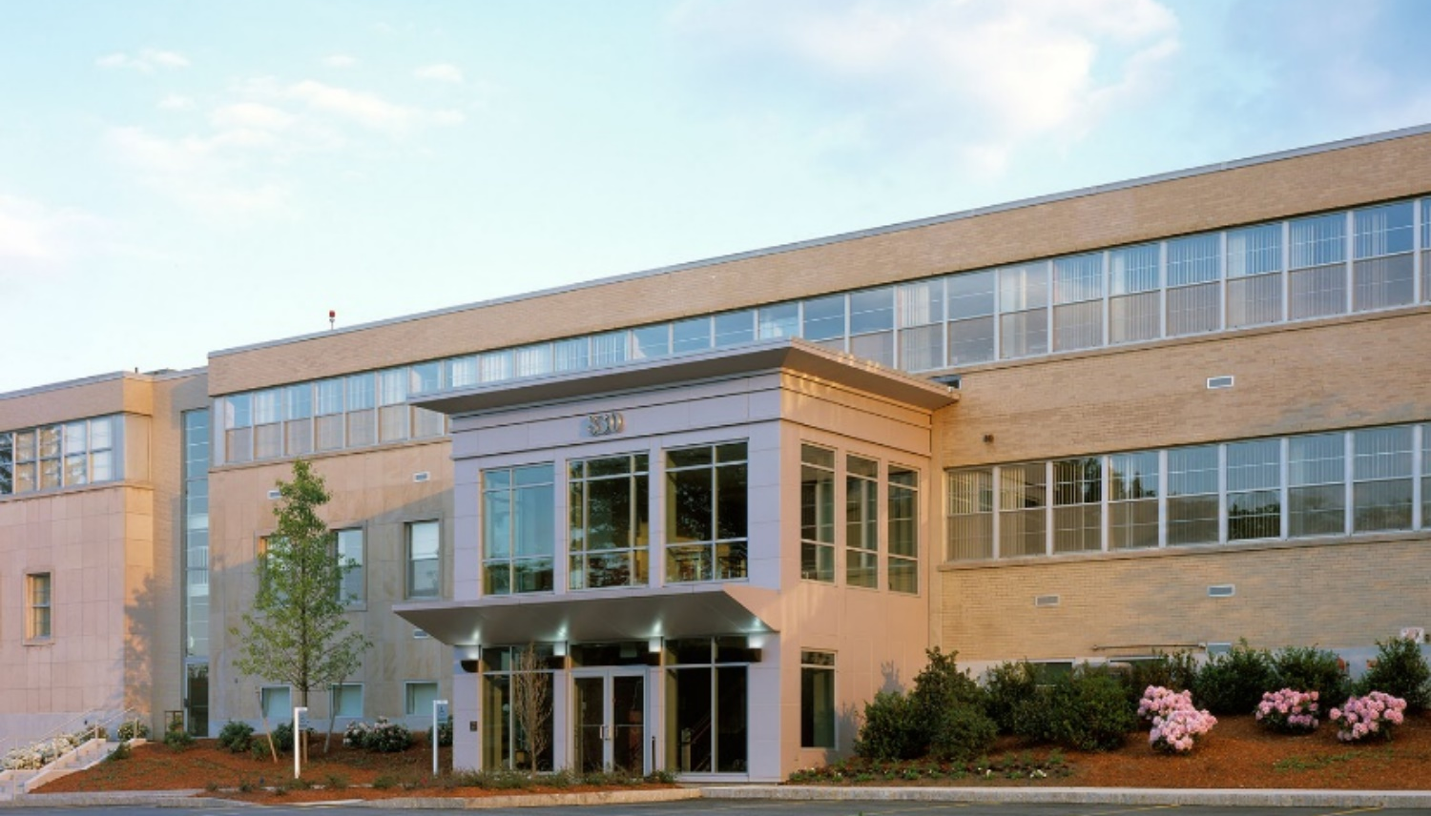
Center for Clinical Investigation’s

Research Off-Campus Clinic - Boylston
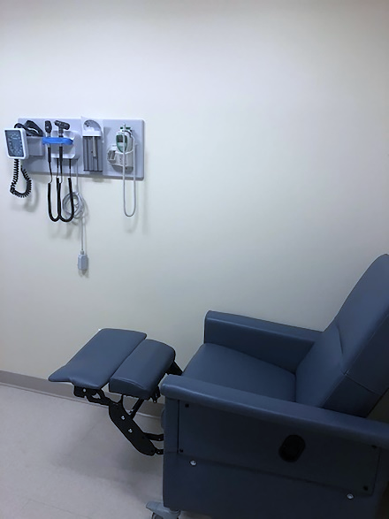
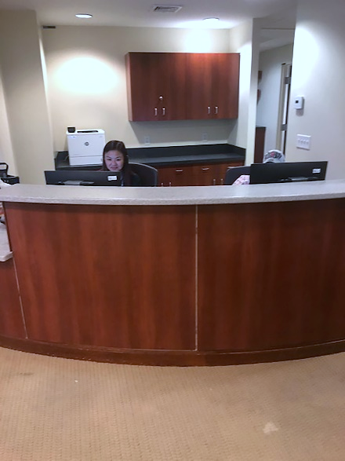
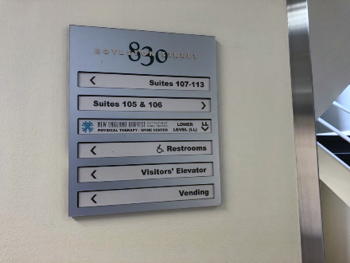
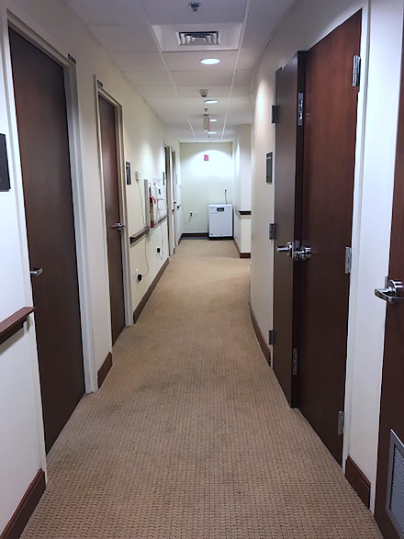
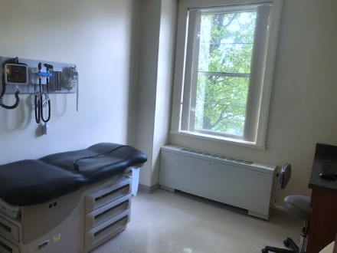
  - OPENING DATE: August 10, 2020
  - HOURS: Weekdays, 7:30 AM to 4:00 PM, Staffed for scheduled visits
  - LOCATION: 830 Boylston Street, Suite 107, Chestnut Hill, MA 02467
  - Phone: (857) 307-1244
Research Off-Campus Clinic - Boylston (ROC-B) is the Center for Clinical Investigation’s new outpatient research clinic. Recognizing that COVID-19 will be a factor in the foreseeable future, the CCI has modified facilities, schedules and safety protocols to prevent the spread of infectious disease and offer a safe care research environment for staff, research teams and subjects. This new clinic expands the safe care research environment beyond the main BWH campus, offering an alternate facility for research visits and subjects that don’t require the resources of the main hospital.

AVAILABLE SERVICES
- Phlebotomy, EKG, BP, Vitals, Height and Weight Services
- Nursing Support
- Licensed Independent Provider (LIP, NP/PA) Support
- IDS Support (if arranged with IDS)
- 5 Exam Rooms
- Touchdown Space
- Free Parking
- Mass Brigham Shuttle Service between BWH Main Campus and 850 Boylston
ROC-B services are like other CCI outpatient clinics, with the following differences:
- BWH Emergency response services are not available at this location. We cannot call a “CODE.”
- Sample processing will not be available at this location.
- Sample transport to the CCI’s CTC simple processing lab may be available upon request.
- Nutrition services will not be available at this location.
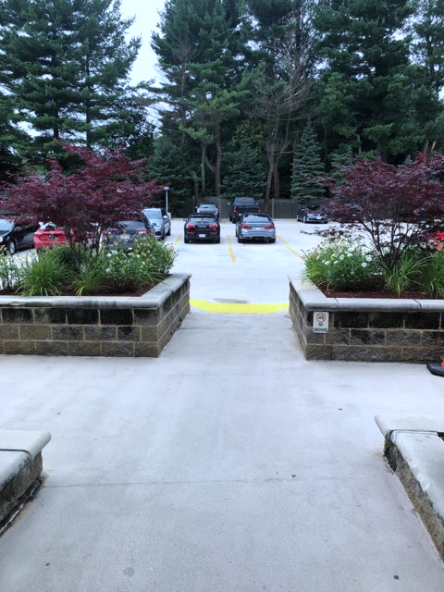
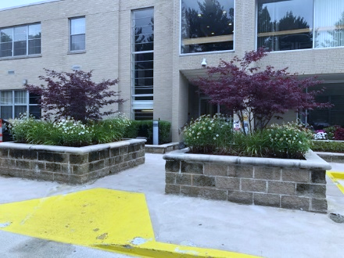
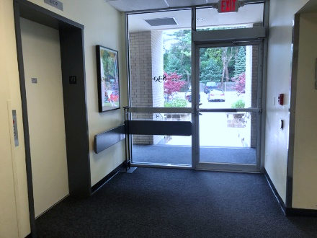
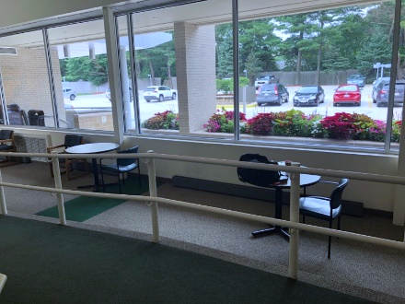
- On-going IDS studies should contact their IDS pharmacist to make sure that using ROC-B is feasible. Most studies will need to pick up their drug on the main BWH campus and bring it to 830 Boylston and the MD/LIP will need to be on site for the research visit. Study teams will be responsible for discussing this requirement with CCI Nursing/LIP team to determine if the drug can be administered at this site without an emergency response, similar to our 221 Longwood site.

SCHEDULING ROC-B:
CCI approved study teams wishing to use ROC-B should update IRB documents to add the performance site of 830 Boylston, submit the CCI resource update form http://www.brighamresearchcci.org/about/additional-cci-resources/ and work with CCI admin team (CCI@bwh.harvard.edu) to create a scheduling template.

VISIT CHECK-IN:
Enter the building through the rear entrance and follow signs to Suite 107. Check-in will be in Suite 107. Research participants will be screened in Suite 107 and the expectation is study staff will do their symptom attestion through the BWH COVID pass prior to arrival. Staff and research participants who have not received masks at BWH main campus will be provided with masks at 830 Boylston.

LOCATION:
CCI’s ROC-B in Chestnut Hill is located just 15 minutes from the Brigham and Women’s Hospital main campus and just one mile east of the Chestnut Hill Mall. Proceed up the driveway to the rear of the building where there is ample free parking. IMPORTANT: Do not follow the street numbers on Route 9 since they change from town to town. The clinic is on Boylston Street in Chestnut Hill, not Boylston Street in Boston (not near the Prudential/John Hancock buildings).

PUBLIC TRANSPORTATION/MBTA:
Take the Green Line to the Kenmore Sq stop. Proceed to street level. Take the Chestnut Hill bus (#60). Once on Route 9, exit the bus at Boylston St @ Reservoir Rd front of the Chestnut Hill fire station immediately prior to the CITGO gas station. Our building is across Rte 9.

PARKING:
Free parking is available on-site for research subjects. Study team members may use the Mass General Brigham shuttle or public transportation.

SHUTTLE:
Look for 850 Boylston on the Mass General Brigham shuttle schedule. This clinic is located next door to 850 Boylston and serviced by the same shuttle drop off/pick up locations. https://www.massgeneralbrigham.org/patient-information/shuttles#schedules

